ADEKUNLE AJASIN UNIVERSITY, AKUNGBA-AKOKO
DEPARTMENT OF COMPUTER SCIENCE

SOFTWARE REQUIREMENT SPECFICATION (SRS) FOR SECURITY INCIDENT MAPPING (SIM) PLATFORM
PREPARED BY: OLOGUNDUDU OLUWAKEMI MARY
MATRIC NO: 241201097
COURSE CODE: COS 202
DATE: JULY 2026

1.1 INTRODUCTION

1.1 PUROSE
The purpose of this document is to specify the complete functional requirement for the security incident mapping (SIM) platform. The SIM platform is engineered as a responsive web-based application designed to bridge the communication gap between community residents and security personnel. By providing a decentralized framework for logging security threat vector, the platform transforms information gathered into actionable and visual intelligence to safeguard the lives and property of campus community members.
1.2 scope of the system
The SIM platform operates strictly as a frontend-driven, location threat-monitoring interface. The system boundary encompasses two primary domains: data ingestion (allowing student, staff, landlords to securely log insecurity incidents while maintaining anonymity) and visual risk assessment (a board containing a interactive map overlay to display high risk coordinates around campus gates and off campus villa)
1.3 project constraint
To ensure rapid development and meet strict evaluation timelines, the system interface must be remained lightweight, utilizing native web technologies (HTML5 and CSS3). Highly complex backend database structure or external mapping API subscriptions are bypassed in this version in favor of a static, mock-data overlay system. The source code must reside entirely on GitHub.

2.0 SYSTEM ARCHITEHURE AND MODELLING
2.1 Root-cause Analysis (Ishikawa Diagram)
To design an effective software solution, a comprehensive root-cause analysis was conducted using a Ishikawa model to identify why of

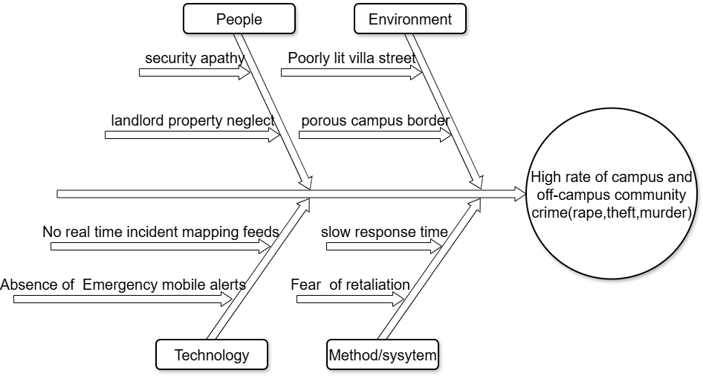
2.2 functional requirement (use case diagram)
The structural interaction within the SIM ecosystem are governed by specializes user roles, mapped explicitly through unified modelling language (UML) standards.
The reporters (students, staff, landlords) possess equal system privileges to view live threat map and execute report security incident function. The system admin handles backend validation, review maps, and manages reports. When a reporter invoke report security incident, the system automatically includes the report anonymity path.
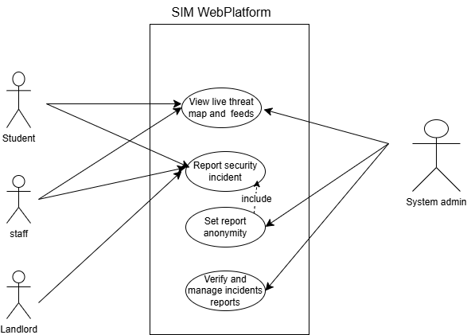

3.1 Data acquisition framework (goggle form specifications)
To ensure reliable and uniform data usage, a structured google form was deployed as the primary usage vector. This framework isolates data into standardized fields to prevent text fragmentation and facilitates seamless synchronization

LIVE FORM LINK: https://docs.google.com/forms/d/169noRsYXIC_P7tkGKyGn80lYPo5tihZbJ42LjpvRjTI/viewform?usp=sf_link
3.2 implementation code listing (unified source code)
The following code listing represents the complete, operational frontend prototype for the SIM platform. To maximize rendering efficiency across mobile devices and bypass standard compilation file-linking constraints, the structural elements (HTML), interface styling rules (CSS), and view-switching page logic (JavaScript) have been engineered into a single unified entry point file.
<!DOCTYPE html>
<html lang="en">
<head>
<meta charset="UTF-8">
<meta name="viewport" content="width=device-width, initial-scale=1.0">
<title>SIM - Security Incident Mapping</title>
<style>
/* General Reset */
* {
margin: 0;
padding: 0;
box-sizing: border-box;
font-family: 'Segoe UI', Tahoma, Geneva, Verdana, sans-serif;
}
body {
background-color: #121212;
color: #e0e0e0;
line-height: 1.6;
}
/* Header & Navigation */
header {
background-color: #1f1f1f;
padding: 1rem 2rem;
display: flex;
justify-content: space-between;
align-items: center;
border-bottom: 2px solid #cf6679;
}
header h1 {
color: #cf6679;
font-size: 1.5rem;
}
nav button {
background: none;
border: none;
color: #e0e0e0;
margin-left: 1.5rem;
font-weight: 600;
font-size: 1rem;
cursor: pointer;
}
nav button:hover {
color: #cf6679;
}
/* Container Layout */
.container {
max-width: 1000px;
margin: 2rem auto;
padding: 0 1rem;
}
/* Page Views toggle */
.page-view {
display: none;
}
.page-view.active {
display: block;
}
/* Dashboard Cards */
.dashboard-grid {
display: grid;
grid-template-columns: 1fr;
gap: 1.5rem;
margin-top: 2rem;
}
@media(min-width: 768px) {
.dashboard-grid { grid-template-columns: 1fr 2fr; }
}
.card {
background-color: #1f1f1f;
padding: 1.5rem;
border-radius: 8px;
border: 1px solid #333;
}
.btn {
display: inline-block;
background-color: #cf6679;
color: #121212;
padding: 0.7rem 1.5rem;
text-decoration: none;
border-radius: 4px;
font-weight: bold;
margin-top: 1rem;
border: none;
cursor: pointer;
width: 100%;
text-align: center;
}
.btn:hover {
background-color: #b15566;
}
/* Map Placeholder */
.map-placeholder {
background-color: #2c2c2c;
height: 300px;
border-radius: 6px;
display: flex;
justify-content: center;
align-items: center;
color: #888;
border: 2px dashed #444;
margin-top: 1rem;
text-align: center;
padding: 1rem;
}
/* Form Styles */
.form-group {
margin-bottom: 1.2rem;
}
.form-group label {
display: block;
margin-bottom: 0.4rem;
color: #bb86fc;
}
.form-group input, .form-group select, .form-group textarea {
width: 100%;
padding: 0.7rem;
background-color: #2c2c2c;
border: 1px solid #444;
color: #fff;
border-radius: 4px;
}
.form-group input[type="checkbox"] {
width: auto;
margin-right: 0.5rem;
}
.checkbox-label {
display: flex;
align-items: center;
color: #e0e0e0;
}
</style>
</head>
<body>

<header>
<h1>SIM Platform</h1>
<nav>
<button onclick="switchPage('dashboard')">Dashboard</button>
<button onclick="switchPage('report-page')">Report Incident</button>
</nav>
</header>

<div id="dashboard" class="container page-view active">
<h2>Campus & Off-Campus Security Overview</h2>
<p>Empowering students, staff, and landlords to map out threat vectors and reduce community crime.</p>

<div class="dashboard-grid">
<div class="card">
<h3>Emergency Actions</h3>
<p>Witnessed or experienced an incident? Submit an anonymous broadcast instantly.</p>
<button class="btn" onclick="switchPage('report-page')">Report New Incident</button>
</div>

<div class="card">
<h3>Live Security Incident Map</h3>
<div class="map-placeholder">
<p>[ Interactive Danger Zone Map Overlay Displaying Here ]</p>
</div>
</div>
</div>
</div>

<div id="report-page" class="container page-view" style="max-width: 600px;">
<div class="card">
<h3>Submit Security Incident Report</h3>
<p style="font-size: 0.9rem; color: #aaa; margin-bottom: 1.5rem;">
Please provide accurate details to safeguard fellow campus community members.
</p>

<form onsubmit="handleFormSubmit(event)">
<div class="form-group">
<label for="crime-type">Type of Security Incident</label>
<select id="crime-type" required>
<option value="">-- Select Incident Category --</option>
<option value="theft">Stealing / Theft</option>
<option value="stabbing">Physical Assault / Stabbing</option>
<option value="rape">Sexual Harassment / Rape</option>
<option value="cultism">Cult-Related Violence / Murder</option>
</select>
</div>
<div class="form-group">
<label for="location">Location (Campus Area or Off-Campus Villa Name)</label>
<input type="text" id="location" placeholder="e.g. Unique Villa, Campus Gate" required>
</div>
<div class="form-group">
<label for="details">Incident Description & Key Details</label>
<textarea id="details" rows="4" placeholder="Provide any tracking descriptors or warning tags..."></textarea>
</div>
<div class="form-group">
<label class="checkbox-label">
<input type="checkbox" id="anonymous" checked>
Hide my identity (Submit Report Anonymously)
</label>
</di>
<button type="submit" class="btn">Broadcast Incident Report</button>
</form>
</div>
</div>

<script>
// Simple Page Switching Logic
function switchPage(pageId) {
// Hide all views
document.querySelectorAll('.page-view').forEach(view => {
view.classList.remove('active');
});
// Show the clicked view
document.getElementById(pageId).classList.add('active');
}

// Mock Submission Handler
function handleFormSubmit(event) {
event.preventDefault();
alert("Incident successfully broadcast to the SIM mapping network!");
switchPage('dashboard');
}
</script>
</body>
</html>

4.1: CONCLUSION
The development of the Security Incident Mapping (SIM)platform satisfies the critical need for a localized, responsive and decentralized crime-tracking framework, by integrating crowdsourced data collection via structured google forms with a high-alert, dark-themed frontend user dashboard, this prototype proves that student, staff, and landlord stakeholders can actively participate in situational safety awareness. The successful implementation, version tracking via GitHub, and modelling through root-cause (Ishikawa)and UML use-case frameworks Layna rock-solid foundation for deployment within the campus ecosystem
4.2: Future Recommendations
While this version serves as an exceptional structural and interface prototype, future iterations can scale the platform int a fully automated enterprise system by adopting the following enhancements:
- Live Database Integration: Transition from static, mock-data arrays to a dynamic database backend (such as Firebase or PostgreSQL) to allow real-time updates to the active incident feed.
- Geospatial API Mapping: Integrate live mapping API’s (such as open street market or Google maps API) to automatically drop GPS-coordinated visual “danger pins” onto the dashboard based on location text inputs.
- Automated Emergency Puah Notifications: Build an SMS or Telegram API webbook service that broadcasts immediate, high-alert mobile warnings to students when a violent threat is verified near campus gates or off-campus gates or off-campus villa clusters

